|  |
| --- |
|  |
| **UNIT TESTING** |
| **PROJECT: ADVENTURE WORKS 2019 DATABASE** |

|  |
| --- |
| IPSITA MOHANTY |

**TESTING OF POWER BI RESULT WITH SQL RESULT**

visualization 1: **Sum of order quantity & Sales amount by month**

* **validate successfully**

**Dashboard page [ 1st]: -**

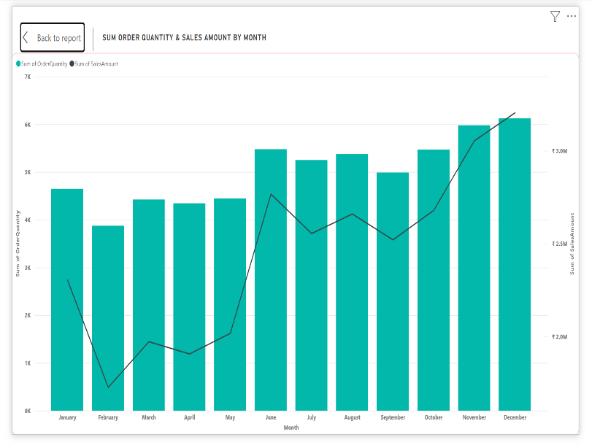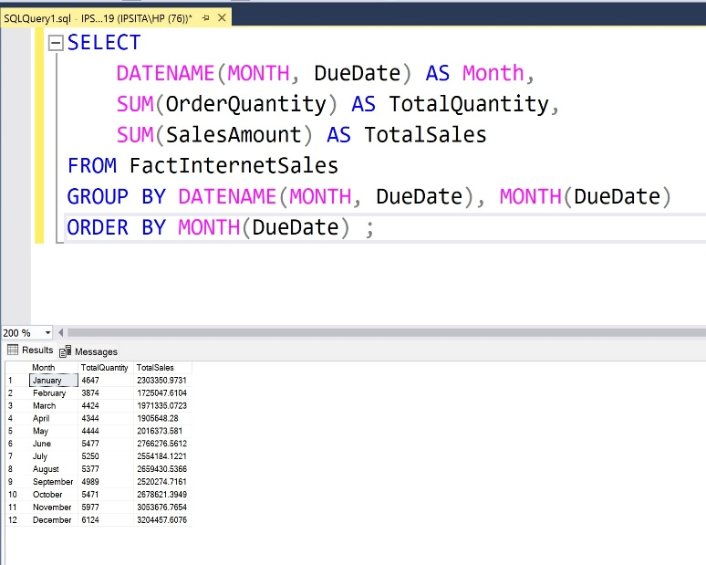**PBI RESULT - SQL RESULT -**

**visualization 2: Sum of Tax amount by colour**

* **validate successfully**

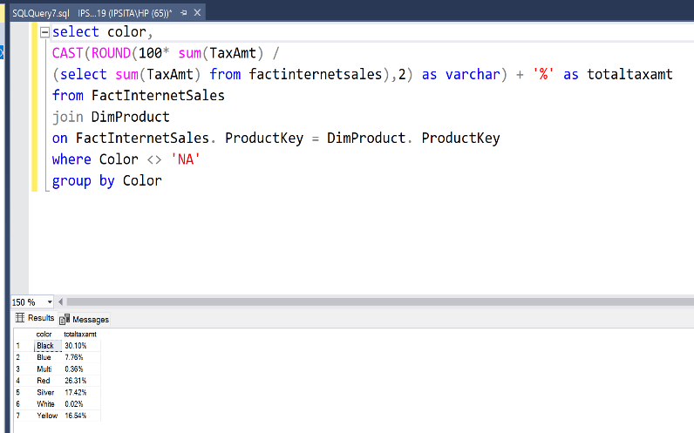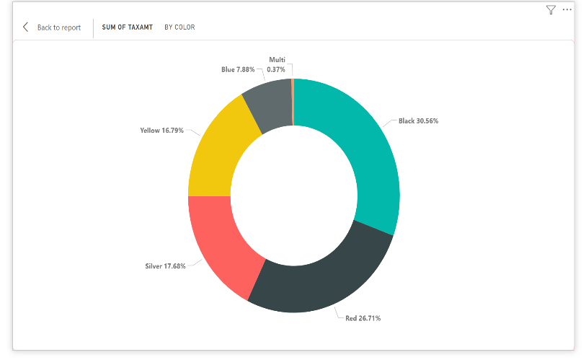**PBI RESULT - SQL RESULT -**

**visualization 3: Total Tax amount**

* **validate successfully**

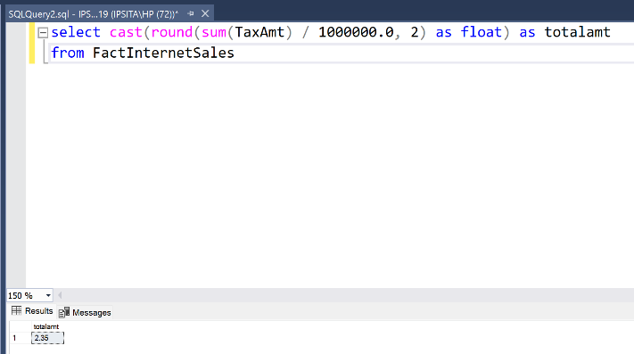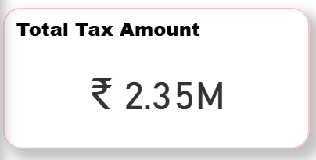**PBI RESULT - SQL RESULT-**

**visualization 4: Total sales amount**

* **validate successfully**

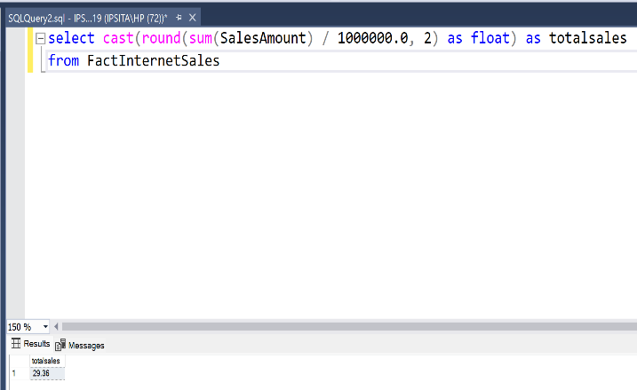**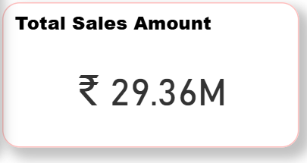PBI RESULT - SQL RESULT-**

visualization 5. Sales amount by sales territory country

* validate successfully

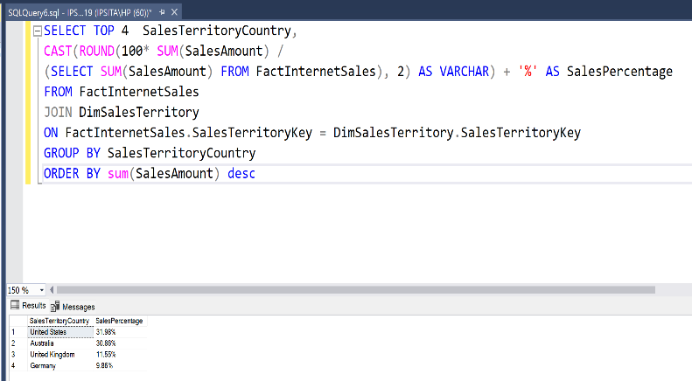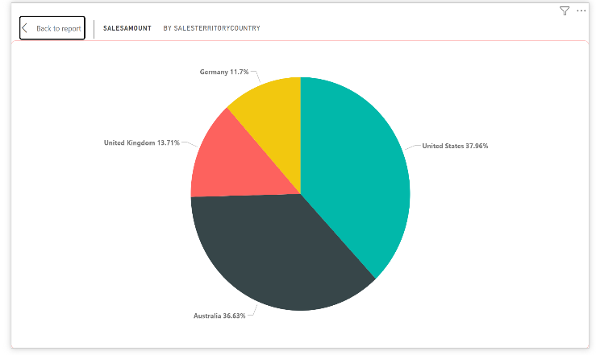PBI RESULT - SQL RESULT -

visualization 6: Sum of order quantity by sales territory region

* validate successfully

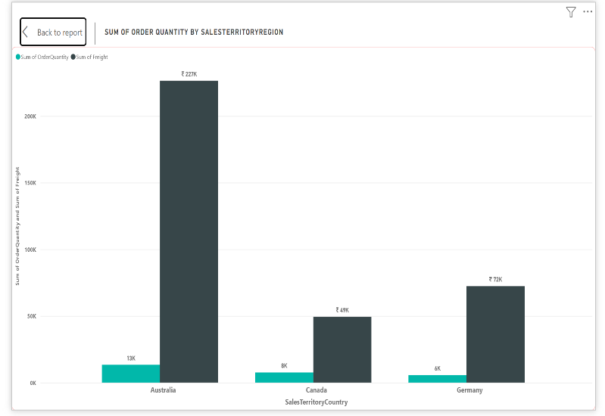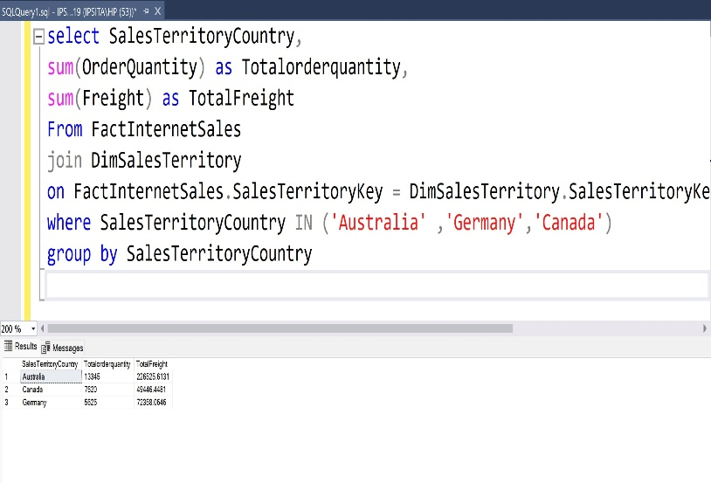PBI RESULT - SQL RESULT -

**Premium Page[ 2nd ]:-**

visualization 7: Table Data structure

validate successfully.

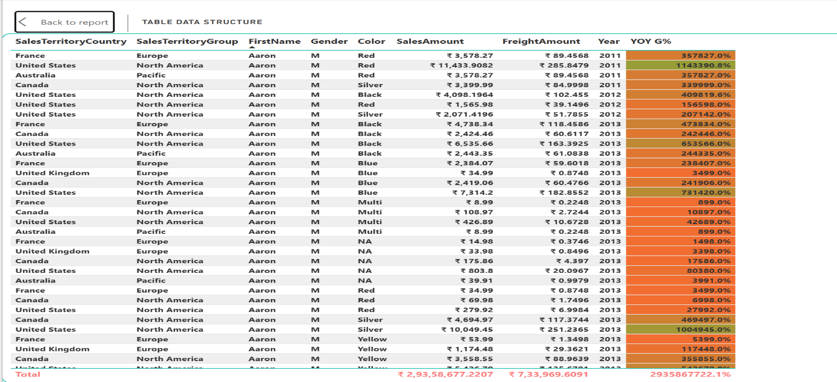PBI RESULT-

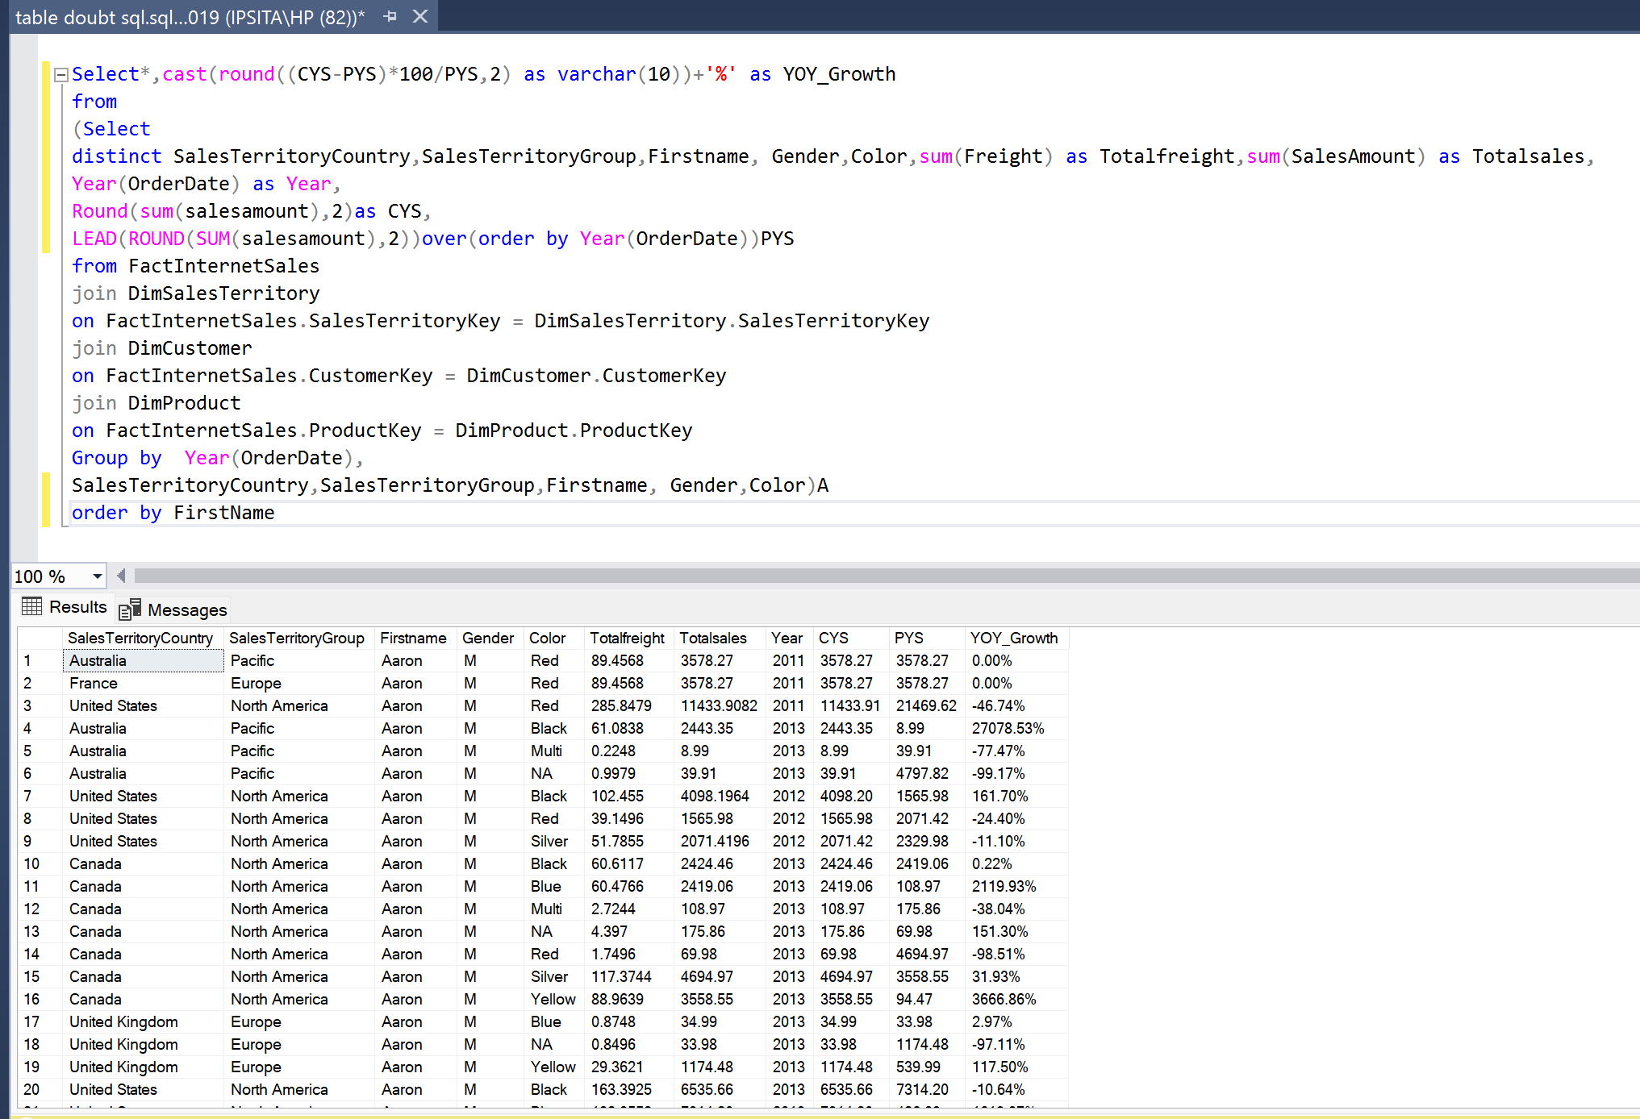SQL RESULT -

visualization 8: COUNT of currency key by sales territory region

* validate successfully

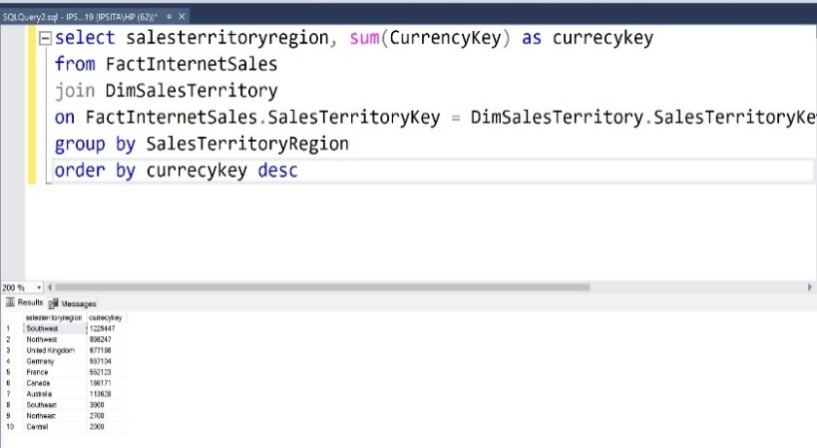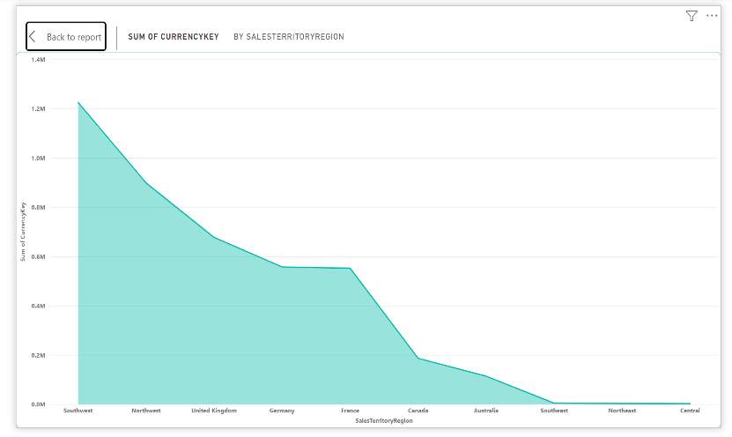PBI RESULT - SQL RESULT -

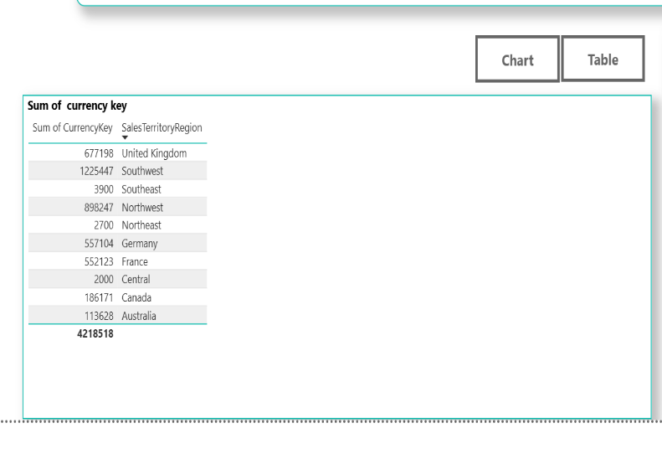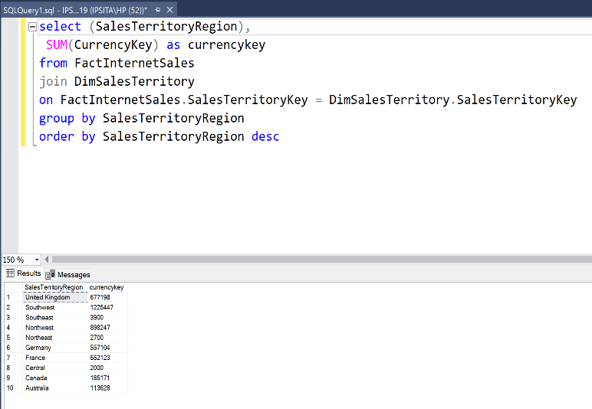PBI RESULT - SQL RESULT-

visualization 9: Sum of tax amount by quarter

* validate successfully

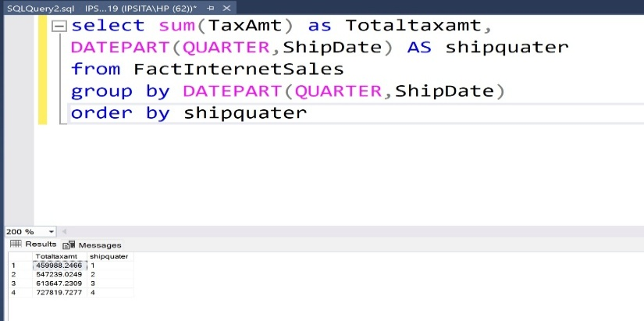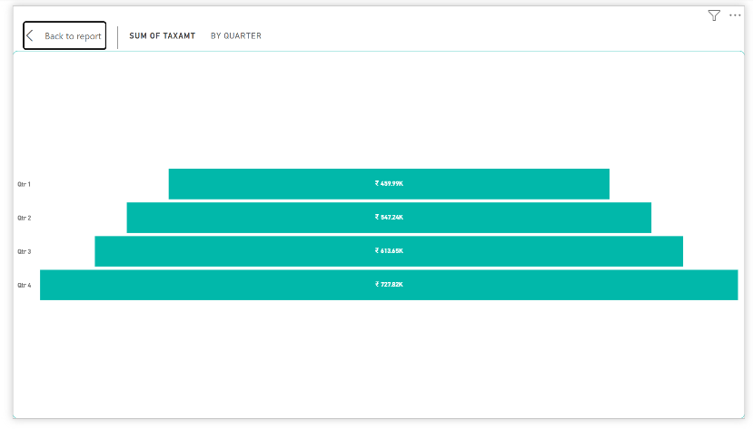PBI RESULT - SQL RESULT -

visualization 10: Slicer as colour

* validate successfully

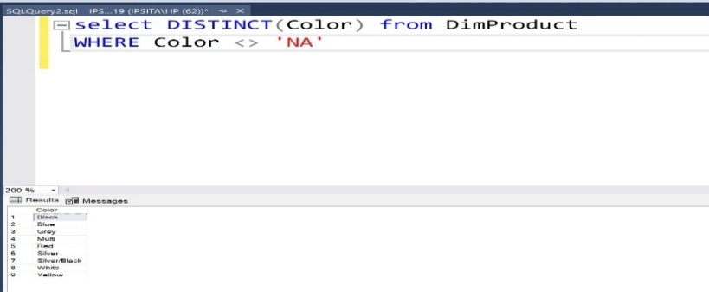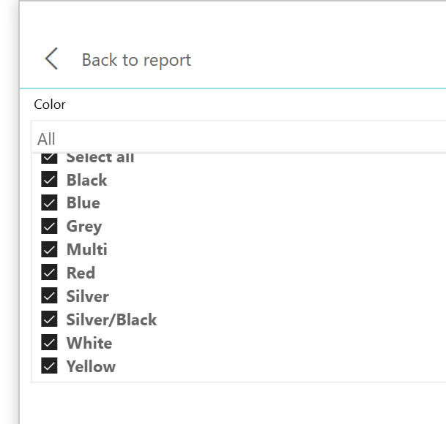PBI RESULT - SQL RESULT -

------------------------------ END ----------------------------

Thank you.